INSTRUCTIONS TO AUTHORS FOR THE PREPARATION OF MANUSCRIPTS FOR GLOBAL STONE CONGRESS 2023
A.A. Surname¹*, B.B. Surname², C.C. Surname³, D.D. Surname¹

- Affiliation of the 1st author, *e-mail@com.pt of the 1st author
- Affiliation of the 2nd author,
- Affiliation of the 3rd author

Summary: An English short summary with a maximum of 150 words in Calibri 10 pt and single spacing 0 pt. Justified text.

Key words: word 1, word 2, word 3, word 4, word 5

Only texts written in English are accepted. Documents must be in Windows or MacOS format, version.
Deadline for submission of papers April 2, the delay compromises the date of publication of the journal. The papers must be introduced on the congress webpage through the link or sent to lopes@uevora.pt.
Each paper should have a maximum of 8 pages, including figures, tables, references and acknowledgments.
The texts included in the figures must be large enough to be read in the figures that make up the body of the article. Pages should have 2.5 cm of top and bottom margins, and 2 cm of side margins in DIN A4 format.
The text must be written in Calibri, 10 pt, formatted in 2 columns of 8.5 cm each, with single spacing and 5 pt between paragraphs.
The magazine will be published online so all images, tables, diagrams and graphs can be submitted in colour. For the printed version, each paper will be entitled to two pages in colour and the authors must clearly indicate the pages to be printed in colour.
Papers will be sent anonymously to the scientific committee for review to an evaluation by a panel of experts. Works whose quality does not reach the minimum required may not be accepted.
The figures must be inserted in the text (Fig. 1), in the corresponding position, adapted to the column, or, adapted to the entire width of the page (Fig. 2). They must be adequately sized and have a minimum resolution of 250 dpi.

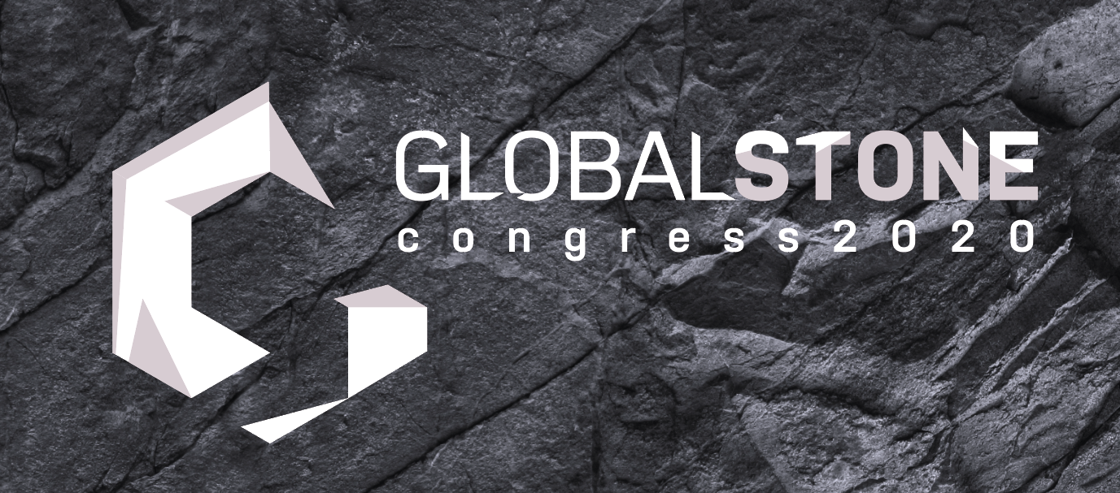
Fig. 1. Figure captions (can be maps, diagrams, photographs, etc.) must be written in italics, 8pt size, with consecutive numbering.
Tables must be numbered independently and in Roman numerals (Table I; Table II; Table III; etc.).
Fig. 2. Full-width figures should look like this.

Acknowledgments: The authors can express their appreciation or acknowledge to support and help their received on their work etc.

References
American Psychological Association (2009). Publication Manual of the American Psychological Association (6th ed.). Washington, DC: Author.
Germano, D.; Lopes, L.; Gomes, C.; Santos, A.; Martins, R. (2014). O Impacte das Pedreiras Inactivas na fauna, Flora e Vegetação da Zona dos Mármores: Problema ou Benefício? Callípole, Revista de Cultura nº 21; Câmara Municipal de Vila Viçosa; pp. 149 – 171.
Guo, H., Todhunter, C., Qu, Q. and Qin, Z., (2015). Longwall horizontal gas drainage through goaf pressure control. International Journal of Coal Geology. 150-151, 276-286.
Juvandes, L.F.P. (2002). Materiais Compósitos Reforçados com Fibras, FRP. Ciência dos Materiais, Licenciatura em Engenharia Civil, Faculdade de Engenharia da Universidade do Porto, Departamento de Engenharia Civil, pp. 76.

